Honey Show Rules

HOST: _Randolph County Beekeepers Association _ (hereinafter: RCBA)
CHAIRPERSONS: _Mark Case EXHIBIT FEE: None
ARRIVAL TIME: ___August 1, 2023_; Between _9:00 AM and _2:00 PM.
LOCATION: Randolph County Cooperative Extension Office,
1001 S. Fayetteville Street, Asheboro NC 27203
JUDGING: : August 1, 2023, Beginning at 2:30 PM
RELEASE TIME: August 1, 2023, between 6:30 PM and 8:30 PM. JUDGES: TBA

SHOW SECRETARY: Mark Case

General Rules of the Honey Show:
- The honey show is open to any who wishes to enter one or more exhibits, except as otherwise specifically provided for herein. The honey show is NOT open to individuals serving as judges, stewards, or show secretaries, nor to individuals who are immediate family members of those individuals serving as judges, stewards, or show secretaries.
- Each Exhibitor must sign an affidavit stating that each exhibit he or she submits was produced by the Exhibitor in conformity with the rules set forth herein.
- Each Exhibitor may make only one exhibit per class. More than one individual from a family or household may submit exhibits across different categories: however, family members and individuals from common households may not submit multiple exhibits in the same category.
- Unless specifically otherwise provided for under an individual category’s rules, ALL honey, beeswax, propolis, pollen, or royal jelly exhibited, or made part of any exhibit, must be produced by the exhibitor from honeybees owned and kept by the Exhibitor.
- All beeswax items, unless otherwise specifically allowed herein, must be prepared from pure, unadulterated beeswax, free from any additives or enhancements. The use of synthetic, artificial, or adulterated beeswax or drawn honeycomb is strictly prohibited. Exhibits found to be containing any of the above will be disqualified.
- Regarding the requirement of uniformity, items within or comprising any single exhibit should be alike and matching in every way: jars, containers, closures, contents, composition, orientation, placement, presentation, etc., should be identical across all individual items comprising any single exhibit.
- Once exhibits have been accepted into the competition by the Show Secretary, they may not be altered in any way.
- After submitting entries to the Show Secretary, exhibitors may not enter the area where the exhibits have been placed.
- The Secretary, Stewards or Judges are the only persons who may enter the honey judging area.
- Judges will enter the honey show area after the close of exhibitor acceptance. This is to ensure as close to a blind judging as possible.
- Exhibits must be unmarked or identifiable in anyway, except as provided herein. The Show Secretary will provide each exhibitor identifying labels to be affixed to each exhibit as provided in the rules for each exhibition class. The Exhibitor shall be responsible for placing the ID labels on each exhibit as directed for each exhibition class, unless otherwise specified herein.
JUDGING & AWARDS:
It is the intention that awards will be given in all classes even if there is only one exhibit in the class. However, in order to receive an award that exhibit must be worthy of placement. Exhibit into a class does not guarantee an award.
All exhibits shall be judged by individuals who are trained and certified Welsh Honey Judges. The Referee shall have final say in any matter pertaining to the contest if called upon and shall have the authority to exclude or disqualify any exhibit(s) for good cause. The Judge(s) shall have the final say regarding the evaluation of any and all exhibits. The decisions of the Referee and Judge(s) are final. Exhibitors found willfully cheating, or purposefully altering or disfiguring an exhibit for the purpose of influencing the validity of judging will be disqualified from the contest.

Club Member Category Prizes:
Ribbons will be awarded as follows:
In each category: First place; Second Place; Third Place; Fourth Place.
Best in Show will receive a rosette.
Awards will be presented at the August 1, 2023, RCBA meeting. The meeting is a covered dish social event, open to all. Bring some food item to share with others.

The following categories will be accepted and judged at the Honey Show. Categories are listed on the affidavit.
Extracted Honey, Black Jar Honey, Beeswax Blocks and Bars ,
Beeswax Candles, Baked Goods Made with Honey

Rules for Individual Classes:

Extracted Honey
Extracted honey is judged in three subclasses: (a) light, (b) medium or amber, and (c) dark. Entrants may submit one exhibit in each of these three classes. One exhibit of extracted honey is defined as three (3) one-pound jars. All forms of extracted honey are to be presented in one-pound, glass (no plastic), “Queen-line” or “Classic” style jars; any exhibits submitted in any other style of jar or container will be disqualified. Closures may be of metal or plastic. Tamper-proof seals are strictly prohibited; any exhibits submitted with any tamper-proof seal(s) will be disqualified. Judges evaluate entries on the following: confirmation with the criteria set forth herein; cleanliness of the jar and lid; correct fill level; uniformity of the jars that comprise the exhibit; cleanliness and clarity of the honey; moisture content (only if needed); and aroma and flavor (for off aromas or flavors). *See Appendix hereafter for notes on correct jars and fill level.

Black Jar
Entries must be transferred to the supplied jar to the fill level. It will be covered to obscure the contents. Judges evaluate entries for flavor only.

Beeswax Bars
An exhibit is defined as three (3) identical one (1) ounce beeswax bars. Preferable color should be lemon yellow with a pleasant, natural beeswax fragrance. The bars should be submitted on a plain, white paper plate, in a zip-top bag. Judges evaluate entries on the following: confirmation with the criteria set forth herein; cleanliness; color; aroma (for off aromas); uniformity; casting flaws; and sharpness of detail.

Beeswax Candles
An exhibit for molded or dipped candles shall consist of two (2) identical candles. The wax should be clean, and free of impurities. Preferable color of the wax should be lemon yellow with a pleasant fragrance. Molded candles must have flat finished bases with wicks well centered. Dipped tapers should have the last drip left on, and the wicks on dipped tapers must be left joined. Molded taper candles must be displayed in an appropriate candle holder. Taper candles will be removed from the holder and replaced after judging. The minimum length of all taper candles is eight inches. Wicks must be waxed and trimmed to one-half inch in length. One candle will be lit.

Judges evaluate entries on the following: confirmation with the criteria set forth in herein; cleanliness; color; aroma (for off aromas); performance; uniformity; casting flaws; and sharpness of detail.

Baked Goods Made with Honey
The Exhibitor may submit one cookie and one bread prepared by the Exhibitor. An exhibit consists of six (6) pieces or servings. The recipe for the exhibit must include honey produced by the Exhibitor. All entries will be tasted. Entries are to be presented on a cardboard base, in a standard, unembellished, cardboard baker’s or cake box; cake boxes with clear windows are also acceptable. All entries will be tasted. Judges evaluate entries on the following: appearance, uniformity, moistness, texture, aroma, flavor, influence of honey on the finished product, and originality. *A 3" x 5" white card with a description of the item and the recipe (including all ingredients & procedure) must accompany each exhibit.

Appendix
*The correct jars for extracted honey entries.
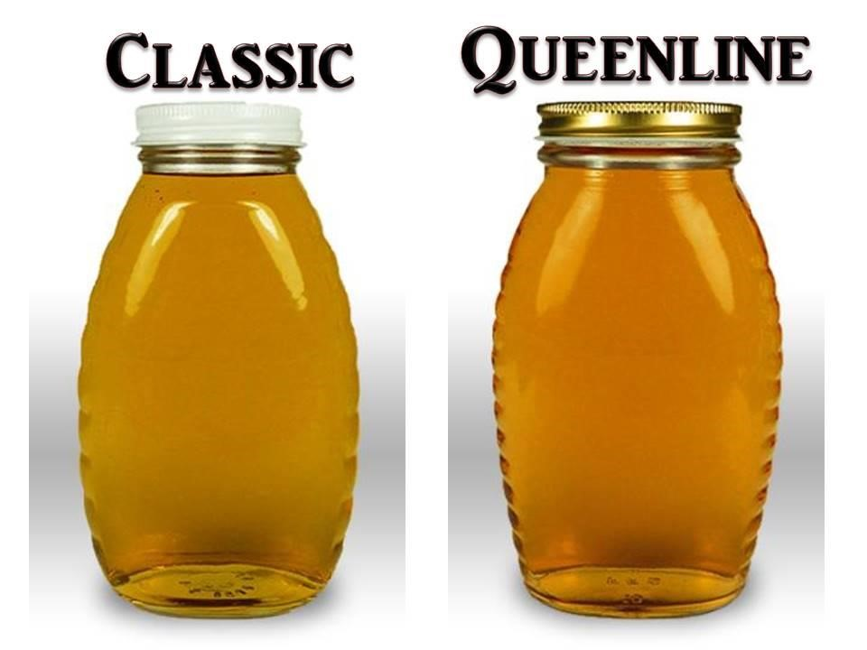

*Notes on correct fill level: The correct fill level on a “Queen-line” or “Classic” style honey jar is at the top of the fill ring of each jar. The fill ring is the raised ridge or ring of glass immediately above the shoulder of the jar, and below the threads. It can be distinguished from the threads in two ways: a) the fill ring forms a complete circle, without ends; and b) the fill ring will be completely parallel with the bottom and top of the jar. There should be enough honey in the jar to reach the top of the fill ring, without going over. Liquid honey in a circular shape forms a concave surface sometimes referred to as a meniscus. For purposes of filling honey jars for exhibition, the edge of the meniscus should meet the top of the fill ring. A jar of honey being over-filled is preferable to one being under-filled.
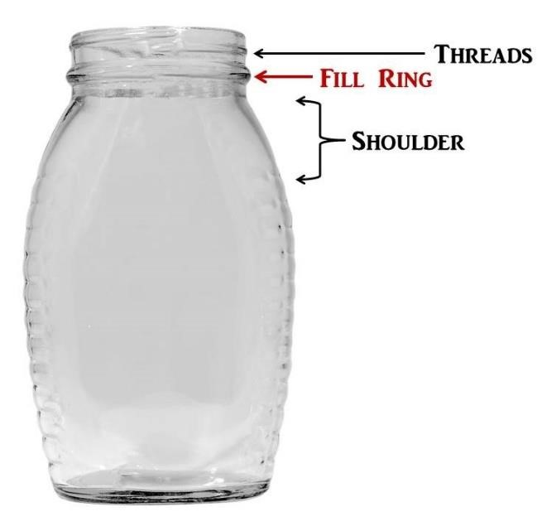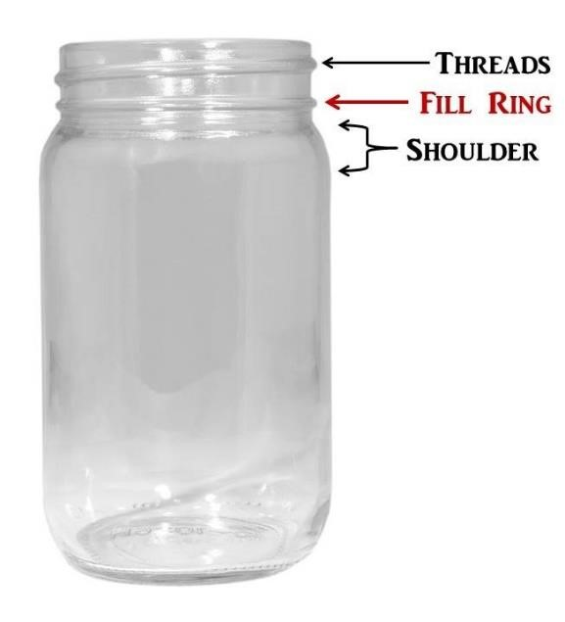

Randolph Beekeepers Association August 2023 Honey Show

Exhibitor #

______ Class F3 Breads Made with Honey
______ Class F4 Cookies Made with Honey
______ Class H1 Light honey (1 lb)
______ Class H2 Medium honey (1 lb)
______ Class H3 Dark honey (1 lb)
______ Class H11 Black Jar

Exhibitor #

______ Class W1 Beeswax Block (1 lb.)
______ Class W2 Beeswax Bars (1 oz.)
______ Class W5 Candles - Dipped Taper
______ Class W6 Candles - Molded Taper
______ Class W7 Candles - Molded Ornamental

Total # of Exhibits: ____________
I hereby certify the Honey Show items I submitted are produced by me and originated from my personal apiary. I also acknowledge that I have read the rules and instructions for preparation and submission of the entries. I understand that my entries will not be accepted for evaluation or award if it is determined they have not been prepared in compliance with the rules and this statement of certification. I hereby accept the evaluation of the judges as the final determination of the awards.

I understand I must retrieve my entries on Saturday, February 25, between 4:00 – 5:00 pm, and that entries not retrieved by the deadline posted for pick-up, shall be deemed abandoned and will be disposed of by the honey show staff.

Print Name: ______________________________________________________________________________

Signature: ______________________________________________________________________________

Phone Number: _____________________________ Cell: _______________________________

Local Bee Club: _____________________________________________________________________________
Mailing Address: ____________________________________________________________________________

Email: _____________________________________________________________________________

(Show Secretary Use) Retrieved Exhibits: ________________________________

